.Name: | _______________________________________________ |  |  | Date: _________
 | Year 10 Mathematics  Test 4, 2015  Topics – Linear Functions and Simultaneous Equations |  |  | 55  = %
Total Time: | 60 minutes | Weighting: | 6% of the year.
 |  | Equipment Allowed: | ½ page notes (A4 one side)
CALCULATOR ALLOWED TEST

1. | [6 marks: 1 mark each]
 | Identify the gradient and y-intercept for each of these equations:
 | Equation Gradient y-intercept

2. | [3 marks]
 | Complete the table of values and draw the graph for the following linear equation:
x | –3 | –2 | –1 | 0 | 1 | 2 | 3
y

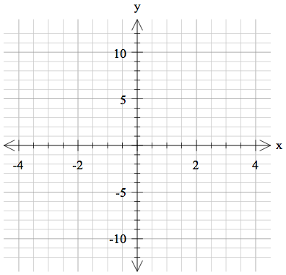
3. | [2 marks: 1, 1]
 | Determine the gradients of each of the lines below:
a) | 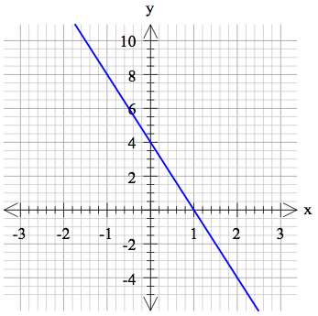 | b) | 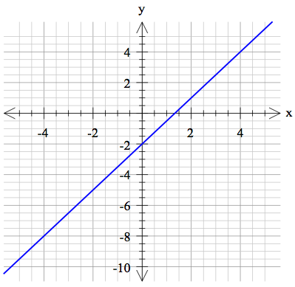

4. | [4 marks: 2, 2]
 | Determine the equation of the line in each of the graphs below:
a) | 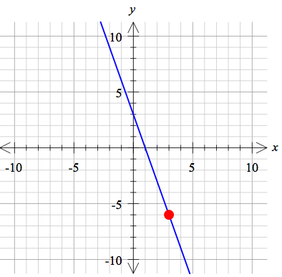 | b) | 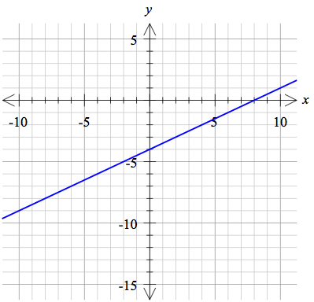
5. | [2 marks: 1, 1]

 | State the point of intersection of each of the following pairs of straight lines.
a) | 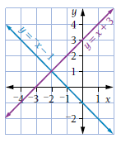 | b. | 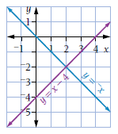
6. | [5 marks: 4, 1]
a)  b) | Use the gradient-intercept method, or the x- and y- intercept method to draw the following line graphs  State the coordinates of the point of intersection
Equation 1: Equation 2:

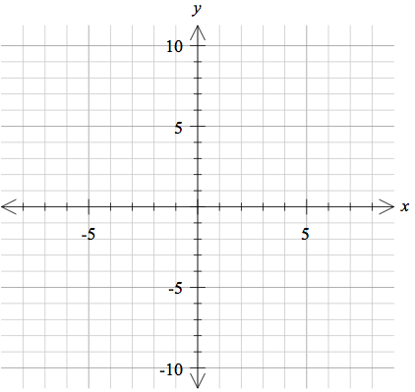

6. | [6 marks: 1 mark each ]
Match each linear equation with its graph
Equation
Graph
Equation
Graph

7. | [2 marks]
 | Determine the equation of the line passing through the point (-3, -5) with a gradient of -1.

8. | [2 marks]
 | Determine the equation of the line passing through the points (2, -4) and (-1, -2)

9. | [2 marks]
 | Determine the midpoint of the line between the points: (4, -2) and (-6, 4)
10. | [2 marks]
 | Determine the distance between the points: (-3, 4) and (3, -1)

11. | [2 marks]
 | Determine the equation of a line parallel to that passes through the point (3, 2).

12. | [2 marks]
 | Determine the equation of the line that is perpendicular to and passes through (-6, -2)

13. | [3 marks]
The sum of two different numbers is 38 and their difference is 24, what are the two numbers?

14. | [6 marks: 2, 2, 2]
 | Use the substitution method to solve the following pairs of simultaneous equations.
a) |  | b)

c)
15. | [6 marks: 2, 2, 2]
 | Use the elimination method to solve the following pairs of simultaneous equations.
a) |  | b)
c)

~ END OF TEST ~

